Viscosity project summary_Section 2_ML_817cP

Table of content

**Standard 817 cP 2**

Set: 1 (amended - real LIN) 2

# Standard 817 cP

Machine learning segment

## Set: 1 (amended - real LIN)

Observation of trends

Observation 1: LIN scaling - divide

Quite a lot of repetition is seen for this set of trials. The test trials are decently accurate which falls within the preferred boundary of -2 to 2%. However, the transfer time is slightly higher than the average derived in standard calibration.

Observation 2: LIN scaling - multiply

There are a few sets of trials that have very long transfer times and the error also ranges from -10 to 2%. Even though it did come across very good parameters, it continued to explore. However, for iteration 3 to 6, one can see efforts of the system trying to fine tune a “favourable” set of parameters.

Observation 3: LIN scaling - none

The sets of parameters suggested are very random, however, the percentage error is maintained between -2 to -3%. There is a combination of very high and very low transfer times (transfer time ranges from 200 to 300s), even though the system did generate a favourable set of parameters, it continued to “explore” new parameters.

Error against iteration diagrams:

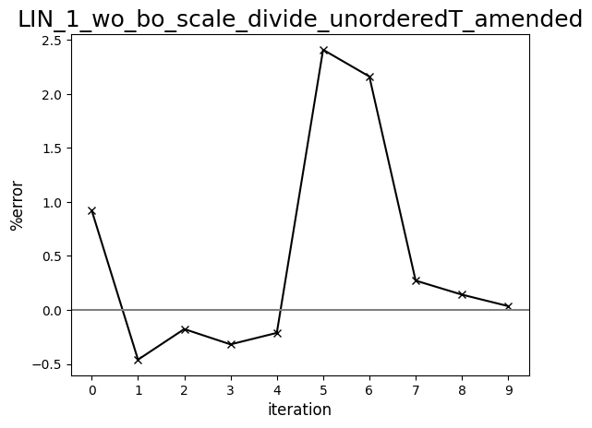

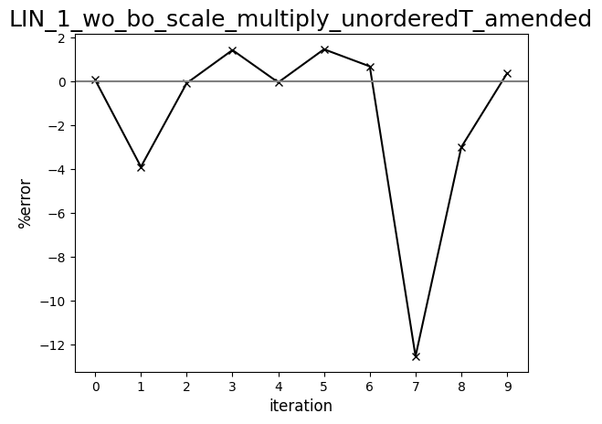

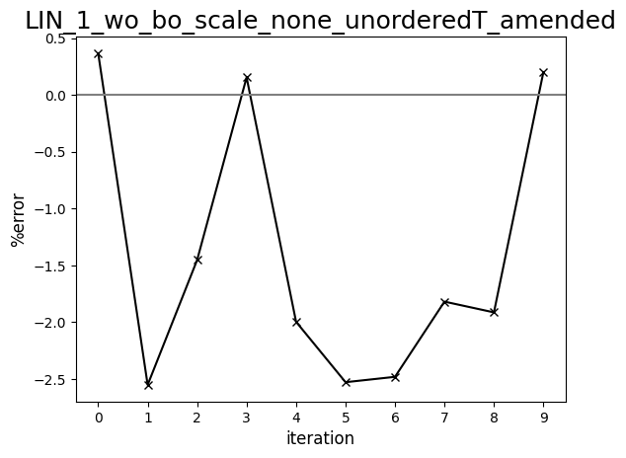

Diagram comparing human-driven and ML test trials (817 cP, set:1, amended - LIN)

